Grace Family Church
Assembly of God
1176 Main St (Rt. 202)
Waterboro, ME 04087
www.GraceFamilyAG.org

Grace Groups Guide

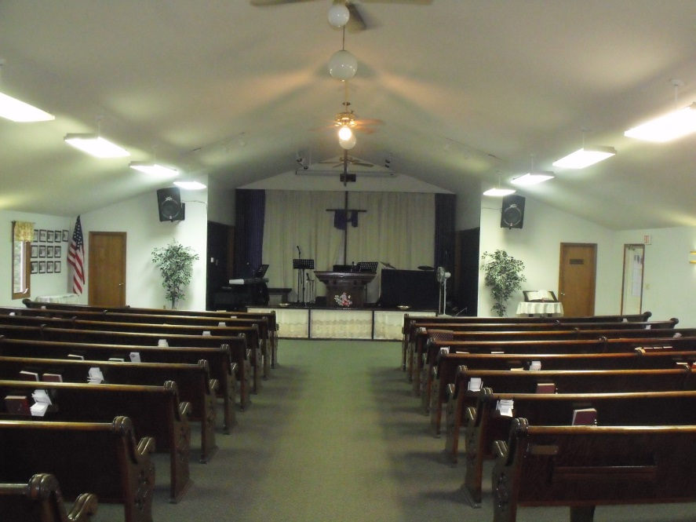
“Get Connected, Grow Together”

Hebrews 10:24-25 (NIV)
And let us consider how we may spur one another on toward love and good deeds, not giving up meeting together, as some are in the habit of doing, but encouraging one another—and all the more as you see the Day approaching.

Introduction:

According to Natural Church Development (NCD) guide, there are eight qualities of a healthy church. They are:

- Empowering Leadership
- Gift-based Ministry
- Passionate Spirituality
- Effective Structure
- Inspiring Worship
- Holistic Small Groups
- Need-oriented Evangelism
- Loving Relationships

Of these eight qualities, Holistic Small Groups is considered to be the most important and vital for the growth and development of a healthy church.

The small groups of Grace Family church will be called Grace Groups. This manual is designed to provide an overview of the purpose, values, procedures and expectations. It will also serve as a guide for leaders and hosts of Grace Groups.

We would like the Grace Group leaders and hosts to serve as “first responders” for their respective groups and provide help and support for their Christian life.

Purpose:

The purpose of Grace Groups is to encourage and enhance relationship with Christ and with one another. In fact, relationship is an essential part of our lives. Individuals, couples, families and even communities thrive in a nurturing environment. First and foremost our relationship should be with our heavenly Father (vertical) and secondly with the fellow believers (horizontal). These relationships nurture and enrich the growth and development of our spiritual life.

Our motto for Grace Groups is “Get Connected, Grow Together.”

G.R.A.C.E.
Grow
Relate
Accept
Connect
Encourage

Values:
The values of Grace Groups are:

1. Christ Centered: Grace Groups are expected to be Christ-Centered and guided by the Holy Spirit.

2. Loving Relationships: Grace Groups are marked by acceptance, inclusiveness, and a place of true fellowship.

3. Trust: Grace Groups will provide a platform for building trust and confidence with one another.

4. Spiritual Growth: Grace Groups will provide an atmosphere for fostering accountability and discipleship for spiritual growth.

Grace Group Meetings:

- The meeting may last for about 90 minutes.
- The group may begin with refreshments, coffee, dessert, snacks, food and time of fellowship (approximately 15 to 20 minutes).
- Opens with prayer.
- Discuss the Sunday sermon and how we can apply what we learned in our walk with Christ (30-45 minutes).
- Reviews the material from the previous week if in a series of messages.
- Time of prayer for individual prayer needs of group members and others.
- The group may include other optional elements such as testimonies, praise reports, etc.
- Close with prayer.
- Clean up at end of meeting with host/leader.

Guidelines:

- Everyone’s opinion is welcomed.
- Keep an open mind.
- Do not take anything personally (even if individual views differ).
- Maintain effective communication (through e-mail, phone, Facebook, texting, etc.)
- Keep confidentiality

Expectations for Grace Group Leaders and Hosts:

- Pray and read the Bible on a regular basis.
- Discuss, review and plan the material before the group meets.
- Arrive early to the group each week.
- Be friendly, encouraging, pleasant, positive, non-confrontational nor easily offended.
- Reach out to group members and newcomers between group meetings.
- Be willing to learn and grow personally.
- Be prepared with materials and questions.
- Enlist group members to help with group elements such as prayer, refreshment, etc.
- Personally apply the material.
- Provide a good example for others.
- Pray for the group and group members during the week.
- Be a good listener encouraging discussion and participation.
- Provide guidance as needed.
- Keep the group on topic, but be open to the guidance of the Holy Spirit.
- Keep the conversation balanced among the members.
- Gently diffuse tense situations.
- Exercise discretion concerning very detailed personal confessions being open to the guidance of the Holy Spirit.
- Provide a clean and neat environment.
- Be hospitable.
- Do not allow gossip.

Evaluate yourselves as Grace Group Leaders and Hosts often:

- Are we open and committed to examining our effectiveness as leaders and hosts frequently?
- Do Grace Group leaders and hosts lead the group in prayer?
- Do leaders and hosts participate in leading discussions?
- When leaders and hosts disagree on a point, are we respectful, calm and polite?
- Do we use some signal if someone is talking too much?
- Do we ask for feedback from Grace Group members about our leadership and effectiveness and are open to criticism?
- Do we review the progress of each class and are we willing and open to learn?

Self-Evaluation and Grace Group Evaluation Forms:

- Self-Evaluation and Grace Group Evaluation Forms will be available to print from www.GraceFamilyAG.org/forms.htm

